Press release  For immediate release  February 18, 2015 | Michelle Hutchison  Head of PR & Money Expert  finder.com.au  +61 403 192 994  +61 2 9299 7602  Michelle@finder.com.au

finder.com.au encourages Australians to compare what matters
- finder.com.au launches multi-million dollar above-the-line media campaign
- Creative message highlights need for Australians to compare things that really matter
- finder.com.au invests further $1 million improving the comparison site for future growth

February 18, 2015, Sydney, Australia – One of Australia’s biggest comparison websites finder.com.au has announced a multi-million dollar advertising campaign to encourage more Australians to compare what really matters: home loans, credit cards, insurance and other financial products.

It’s the first time the Australian-owned comparison website has launched a major above-the-line campaign, which includes free-to-air TV, Foxtel, radio, Youtube, digital and social media advertising.

The creative idea behind the campaign was developed and produced by Radical Love, setting the scene at a corner store where two brothers are carefully comparing pieces of a chocolate bar side by side.

The four-week campaign kicks off today (February 18) online through display, social media and Youtube, TV on February 22 and radio on February 23, with a simple message about the importance of comparing financial products that even kids can appreciate.

Click here to view and embed the TVC: http://youtu.be/4VeyuZ_zaVY

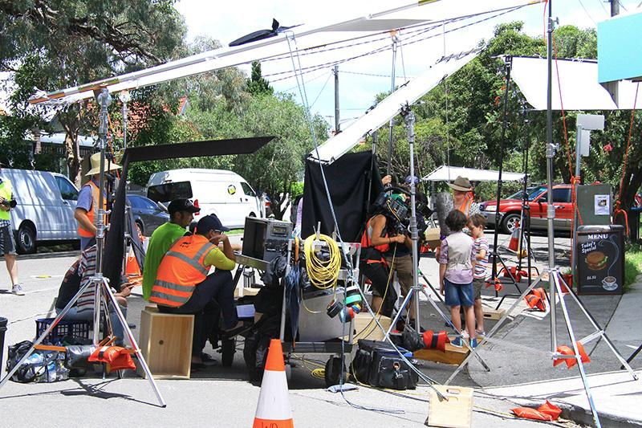

Fred Schebesta, Co-founder and Director of finder.com.au, said the campaign was designed to highlight the need for more Australians to compare their financial products.

“Too many Australians don’t compare the things that actually matter. As kids, we compared everything with each other. As adults, most of us still spend hours comparing trivial things but financial products are often forgotten.

“It’s time Australians knew who finder.com.au is because everyone should compare their financial products side by side and find better.”

Established in 2006 by Mr Schebesta and Co-founder and Director Frank Restuccia, finder.com.au is now one of the biggest comparison websites in Australia with over half a million Australians comparing financial products each month.

finder.com.au also invested over $1 million in the lead up to the campaign, with key hires and new technology, to prepare for the growing number of Australians visiting the website.

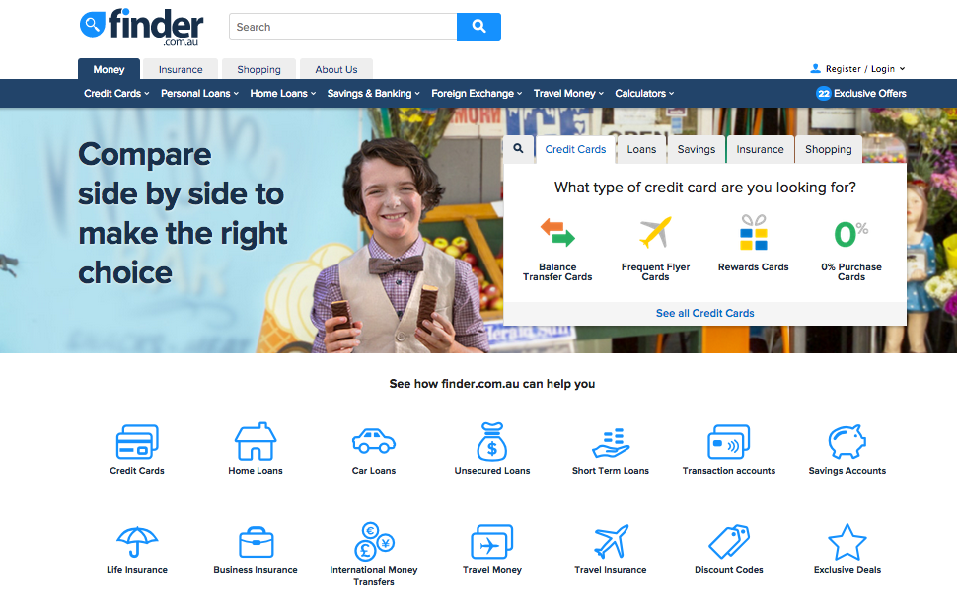
finder.com.au’s newly designed homepage

“We love empowering and inspiring people to want better. finder.com.au provides the tools to understand what that is and how to find it,” said Mr Schebesta.

“Our research shows that the majority of Australians don’t compare their financial products, with over two in five people (42 percent) heading straight into their bank branch while another 40 percent apply directly through their provider online.

“Many Australians love to compare things but not enough compare what really matters. We want more people to get online, compare the deals available and learn more about money because you can find better.”

finder.com.au plans to grow its Australian business this year, improve its existing categories, establish new categories to compare more products and perpare the global launch of finder.com.

Credits:
Client: finder.com.au
Creative Agency: Radical Love
Director: Anthony MacFarlane
Media Agency: Taska Media
Big Brother: Daniel Page
Little Brother: Tom Poulton

###

For further information:
Michelle Hutchison
Head of PR & Money Expert
finder.com.au
+61403 192 994
+61 2 9299 7602
Michelle@finder.com.au

About finder.com.au:
finder.com.au is one of Australia’s biggest comparison websites and has helped over five million Australians find better credit cards, home loans, life insurance, shopping deals and more since 2006. finder.com.au compares thousands of credit and debit cards, home loan products, life insurance providers as well as online shopping promo codes, travel insurance and more. There are over 500,000 Australians who visit finder.com.au to compare financial products every month. December 2014 saw more than 600,000 unique browsers, making it the number one financial comparison website in Australia for the month. There are at least one Australian every five minutes using finder.com.au or one of its network sites creditcardfinder.com.au and lifeinsurancefinder.com.au to find better (Source: Google Analytics).

Disclaimer:
Hive Empire Pty Ltd (trading as finder.com.au, ABN: 18 118 785 121) provides factual information, general advice and services on financial products as a Corporate Authorised Representative (432664) of Advice Evolution Pty Ltd AFSL 342880. Please refer to our FSG and Credit Licence ACL 385509. We are also a Corporate Authorised Representative of Countrywide Tolstrup Financial Services Group Pty Ltd. ABN 51 586 953 292 AFSL 244436 for the provision of online travel insurance. We are not owned by any Bank or Insurer and we are not a product issuer or a credit provider. Although we cover a wide range of products, providers and services we don't cover every product, provider or service available in the market. We also don't recommend specific products, services or providers. If you decide to apply for a product or service through our website you will be dealing directly with the provider of that product or service and not with us. We recommend consumers understand the Product Disclosure Statements before deciding if a product is right for them (c) 2013.

Experian Hitwise 2013, 2014
1,000 Australians surveyed commissioned by finder.com.au and conducted through Google Consumer Survey, August 2014
Experian Hitwise 2013, 2014

