Press release  For immediate release  June 22, 2015 | Michelle Hutchison  Head of PR & Money Expert  finder.com.au  +61403 192 994  +61 2 9299 7602  Michelle@finder.com.au  @finder_news

Workplace safety risk: 200,000+ Aussies not compensated for work-related injuries
- Almost two in five Australians not compensated for injuries sustained at work
- 41,216 Australians spent over two working weeks out of action and without any financial support
- Men found to be more likely to take time off, but women more likely to be injured off-site

June 22, 2015, SYDNEY – More than 200,000 Australians who experienced injuries or illnesses on the job were not compensated last financial year, despite the majority needing time off work, research by one of Australia’s biggest comparison websites, lifeinsurancefinder.com.au revealed.

The lifeinsurancefinder.com.au new study of figures from the latest Australian Bureau of Statistics’ latest Work Related Injuries Australia revealed that 531,800 people experienced a work-related injury or illness for the year, of which 205,600 or almost two in five people (38.7 percent) did not receive compensation, including paid sick leave.

One in five Australians (106,500) who were injured or fell ill at work took two working weeks or longer to recover. This included an estimated 41,216 people who weren’t financially compensated.

While most Australians who fell ill or were injured at work took time off to recover, almost two in five people (38.6 percent) or 205,100 didn’t take time off work.

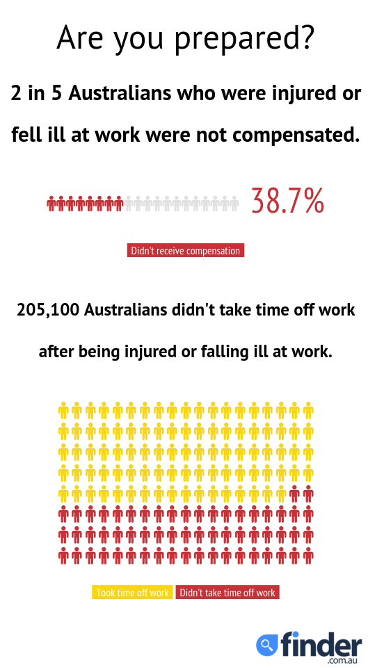

To embed this interactive graphic:
Javascript | iframe
<script id="infogram_0_are_you_prepared" src="//e.infogr.am/js/embed.js?l6s" type="text/javascript"></script> | <iframe src="//e.infogr.am/are_you_prepared?src=embed" width="550" height="1216" scrolling="no" frameborder="0" style="border:none;"></iframe>

Michelle Hutchison, Money Expert at lifeinsurancefinder.com.au, said the number of people who are not aware of their compensation rights is worrying.

“It’s alarming that so many Australians aren’t taking steps to cover themselves and their households financially. Our research shows that over 40,000 Australians who were injured or fell ill at work didn’t receive compensation or sick leave because they either weren’t aware or didn’t think they were eligible.

“Another 16,000 people didn’t take out compensation due to a perceived negative impact on their current or future work.”

Work-related injury or illness
- Sprain/strain: 33.1%
- Chronic joint or muscle condition: 21.1%
- Cut/open wound: 14.2%
- Crushing injury/internal organ damage: 8.6%
- Fracture: 6.8%
- Other: 6.2%
- Stress or other mental condition: 4.8%
- Burns: 4.3%
- Superficial injury: 0.9%
Ranked by highest proportion of injuries/illnesses, Source: ABS Work Related Injuries Australia, lifeinsurancefinder.com.au

The lifeinsurancefinder.com.au research also found that while 91 percent of these work-related injuries and illnesses occurred on-site (483,600), women were more than twice as likely to be injured travelling to or from work (8,600 women compared to 3,700 men). Surprisingly, women were also more prone to being injured during lunchtime or break activities than men (6,700 compared to 5,700).

“Australians need to take action to prevent their bank accounts from taking a hit, should they be put out of work due to injuries or illness. This is especially the case if you provide for a household or have rolling financial commitments such as rent or bills.

“Finding suitable income protection can be one way to weaken the blow of a work-related injury or illness, and can give you a financial crutch to lean on while you’re recovering – just don’t be one of the two in five who don’t make the effort to find compensation,” said Mrs Hutchison.

More findings from lifeinsurancefinder.com.au research:

Men vs Women:
- More women sustained injuries from vehicle accidents, at 13,200 females compared to 11,100 men.
- Women were more likely to experience burns and crushing injuries, while men took more time off due to stress, fractures, cuts/open wounds and superficial injuries
- Men were more likely to fall from a height (making up 4.5% of all injuries, compared to women with 3%). Similarly, men were slightly more likely to fall on the same level (making up 13% of all injuries as opposed to women with 12.5%).
- Overall, men were more likely to take time off due to injury than women, with 65,000 men taking more than two working weeks off. This compares to 30,300 women.

Why they didn’t receive compensation:
- 46% of cases (or 94,700) related to a minor injury or one where compensation wasn’t considered necessary
- 16,000 people did not apply for compensation due to a perceived negative impact on their current or future work
- 8,000 people thought the process was inconvenient or required too much effort or paperwork

Where injuries occurred:
- The workplace accounted for over 91% of injuries, or 483,600 cases.
- Of those remaining, 4.4% or 23,600 cases occurred travelling on business, while 12,300 (2.3%) occurred travelling to or from work.
- There were also 12,400 incidents that occurred during lunchtime or break activities.

###

We now have a news feed on Twitter! Follow us for the latest updates or drop us a line to say hi: @finder_news.

For further information:
Michelle Hutchison Bessie Hassan
Head of PR & Money Expert PR Manager
finder.com.au finder.com.au
+61403 192 994 +61402 567 568

+61 2 9299 7602 + 2 9299 7602
Michelle@finder.com.au Bessie.Hassan@finder.com.au

About finder.com.au:
finder.com.au is one of Australia’s biggest comparison websites and has helped over 4.8 million Australians find better credit cards, home loans, life insurance, shopping deals and more since 2006. finder.com.au compares 250 credit and debit cards from 31 providers, over 300 home loan products, and information from 13 life insurance providers as well as online shopping promo codes, mobile phone plans, travel insurance and more. One Australian every five minutes is using finder.com.au or one of its network sites creditcardfinder.com.au and lifeinsurancefinder.com.au to find better (Source: Google Analytics).

Disclaimer:
Hive Empire Pty Ltd (trading as finder.com.au, ABN: 18 118 785 121) provides factual information, general advice and services on financial products as a Corporate Authorised Representative (432664) of Advice Evolution Pty Ltd AFSL 342880. Please refer to our FSG and Credit Licence ACL 385509. We are also a Corporate Authorised Representative of Countrywide Tolstrup Financial Services Group Pty Ltd. ABN 51 586 953 292 AFSL 244436 for the provision of online travel insurance. We are not owned by any Bank or Insurer and we are not a product issuer or a credit provider. Although we cover a wide range of products, providers and services we don't cover every product, provider or service available in the market. We also don't recommend specific products, services or providers. If you decide to apply for a product or service through our website you will be dealing directly with the provider of that product or service and not with us. We recommend consumers understand the Product Disclosure Statements before deciding if a product is right for them (c) 2013.

Total 205,600, ABS Work Related Injuries Australia, November 2014
_{Experian Hitwise since 2013}
Period of study was July 2013-June 2014

