Press release  For immediate release  June 29, 2015 | Michelle Hutchison  Head of PR & Money Expert  finder.com.au  +61403 192 994  +61 2 9299 7602  Michelle@finder.com.au  @finder_news

Australians put cars, gambling and love lives before their money!
- Personal Finance least searched out of 8 online industries in Australia
- Real Estate most popular industry, with more than 52 million average monthly visits
- Australians need to set their priorities to save more money!

June 29, 2015, SYDNEY – When it comes to weighing up information online, Australians care more about cars, gambling and dating than saving money, according to new research from finder.com.au, one of Australia’s largest comparison websites.

An analysis of Hitwise search traffic data for the eight major online comparison industries in Australia revealed that Personal Finance is the least searched industry, attracting just under three million average monthly visits this year (January-May 2015).

finder.com.au research, which involved analysing the traffic for three leading websites in each category, also found that visitors were 18-times more likely to search for Real Estate, making it the most popular industry and averaging almost 53 million monthly visits. This was followed by Jobs, which saw Australians searching 15-times more than personal finance with 43.6 million monthly visits, while Cars and gambling were search seven-times more.

Industry | Av 2015 monthly visits | More searches than Personal Finance
Real Estate | 52,951,447 | 18x
Jobs | 43,596,399 | 15x
Cars | 19,808,301 | 7x
Gambling | 21,345,608 | 7x
Hotels | 14,200,314 | 5x
Dating | 13,900,094 | 5x
Flights | 11,609,845 | 4x
Personal Finance | 2,870,624 | 1x
source: finder.com.au, Hitwise

Michelle Hutchison, Money Expert at finder.com.au, says the findings are alarming.

“These results are disappointing, especially when you consider the potential savings that Australians can make by using financial comparison websites. For example, comparing home loans and switching to a better deal can save you tens of thousands, even hundreds of thousands of dollars, over your loan term.

“Buying a property is probably the biggest purchase in your lifetime, so it perplexes me that people are not making the effort to do more cost-savings research in this area online. Comparing home loans is just as important, if not more than comparing property online.

“Even Flights and Hotel industries both attract more searches than Personal Finance, despite cost savings may be minimal in this space compared to banking products.

“My advice: be proactive, get online and compare your finance options so you can make a better informed decision for your personal situation – and your wallet.”

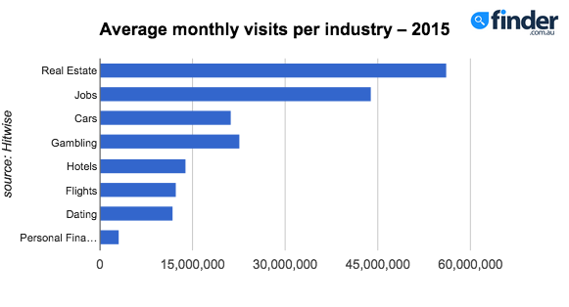

###

We now have a news feed on Twitter! Follow us for the latest updates or drop us a line to say hi: @finder_news.

For further information:
Michelle Hutchison Bessie Hassan
Head of PR & Money Expert PR Manager
finder.com.au finder.com.au
+61403 192 994 +61402 567 568

+61 2 9299 7602 +2 9299 7602
Michelle@finder.com.au Bessie.Hassan@finder.com.au

About finder.com.au:
finder.com.au is one of Australia’s biggest comparison websites and has helped over 4.8 million Australians find better credit cards, home loans, life insurance, shopping deals and more since 2006. finder.com.au compares 250 credit and debit cards from 31 providers, over 300 home loan products, and information from 13 life insurance providers as well as online shopping promo codes, mobile phone plans, travel insurance and more. One Australian every five minutes is using finder.com.au or one of its network sites creditcardfinder.com.au and lifeinsurancefinder.com.au to find better (Source: Google Analytics).

Disclaimer:
Hive Empire Pty Ltd (trading as finder.com.au, ABN: 18 118 785 121) provides factual information, general advice and services on financial products as a Corporate Authorised Representative (432664) of Advice Evolution Pty Ltd AFSL 342880. Please refer to our FSG and Credit Licence ACL 385509. We are also a Corporate Authorised Representative of Countrywide Tolstrup Financial Services Group Pty Ltd. ABN 51 586 953 292 AFSL 244436 for the provision of online travel insurance. We are not owned by any Bank or Insurer and we are not a product issuer or a credit provider. Although we cover a wide range of products, providers and services we don't cover every product, provider or service available in the market. We also don't recommend specific products, services or providers. If you decide to apply for a product or service through our website you will be dealing directly with the provider of that product or service and not with us. We recommend consumers understand the Product Disclosure Statements before deciding if a product is right for them (c) 2013.

_{Experian Hitwise since 2013}

